Spring Boot

1. Spring boot is an module of the spring from which we speed up the development
2. Spring Boot makes it easy to create stand-alone, production-grade Spring based application that you can just run
3. It provides an easier and faster way to set up, configure, and run both simple and web-based applications

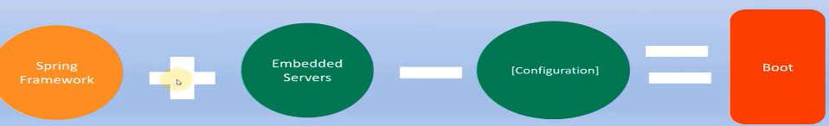

1. Spring boot follows Convention over configuration software design style